

***Object Oriented Programming***

**Name:** Abdul Moiz

**Submitted to:**  Mam Shaista

**Submitted by:** BSCS-2K24-404

**Section :** Y

Task 1

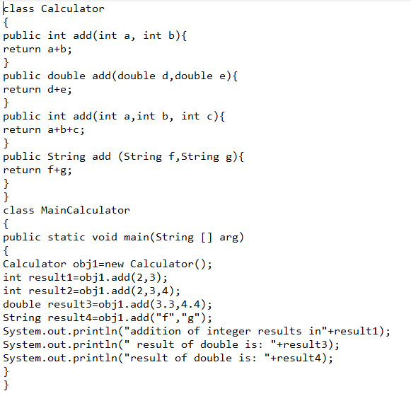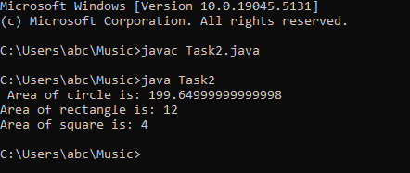

Task 2

